**TASK 1**

**Page 143 – bottom left**

**Work with a partner. Discuss the following:**

* Describe the boy in the picture. Think about *age*, *eyes*, *hair*, *clothes*.
* How does he feel? Happy? Sad? Worried? Why?
* What kind of person do you think he is?
* What do you think his life is like? Think about *school*, *food*, *hobbies* etc.
* If you could meet this boy, what would you ask him?
* How do you think this boy’s life is different from yours?

**TASK 2**

Writing Tasks

* A page from this man’s diary
* An interview with the man
* Advice for someone travelling to the Arctic

**TASK 3**

**Describe a job that you would like to have.**

You should say:

* what the job is
* what it involves
* what its good points are
* what its bad points are

and why it would suit your personality.

**Describe a job that you would like to have.**

You should say:

* what the job is
* what it involves
* what its good points are
* what its bad points are

and why it would suit your personality.

**TASK 4**

**Describe a place that you would like to visit.**

You should say:

* where it is
* what the weather is like there
* how you would travel there
* what you might need to take with you

and why you are interested in visiting this place.

**TASK 5**





**TASK 6**



**TASK 7**



**TASK 8**



**TASK 9**

|  |  |  |  |
| --- | --- | --- | --- |
| 1 | freezing | A | a living |
| 2 | brightly | B | center |
| 3 | extended | C | plant |
| 4 | make | D | painted |
| 5 | hunting | E | training program |
| 6 | day care | F | temperatures |
| 7 | job | G | an opportunity |
| 8 | provide | H | resources |
| 9 | natural | I | family |
| 10 | power | J | trip |

**TASK 10**

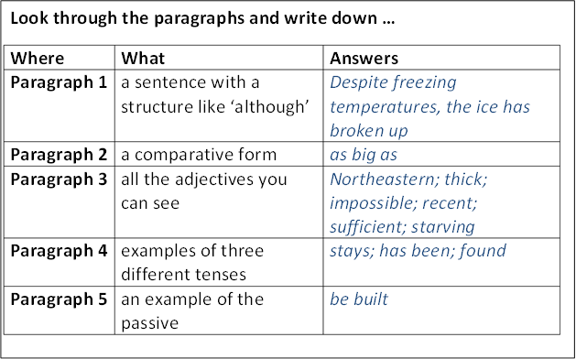

**TASK 11**



**TASK 12**

**Vocabulary**

**All of these words appear in the video clip you have just watched. For each one, write down the connected form. The first is done as an example.**

|  |  |  |  |
| --- | --- | --- | --- |
| **#** | **Word** | **Change to …** | **Answer** |
|  | measure (v) | noun | ***measurement*** |
| 1 | varied (v) | noun |  |
| 2 | reflect (v) | noun |  |
| 3 | strengthen (v) | opposite |  |
| 4 | decrease (v) | opposite |  |
| 5 | predict (v) | noun |  |
| 6 | frequent (adj) | opposite |  |
| 7 | drought (n) | opposite |  |
| 8 | extinction (n) | adjective |  |
| 9 | reduce (v) | noun |  |
| 10 | require (v) | noun |  |